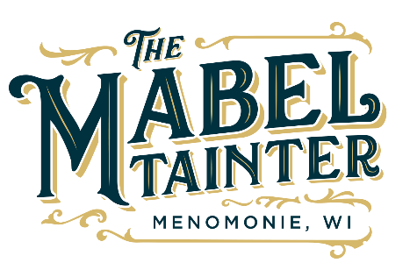
The Mabel Board of Directors Meeting Agenda
The Mabel Tainter mission is to strengthen and connect our community by engaging people in the arts.

If a guest wishes to attend a board meeting, call 715-235-0001 or email director@mabeltainter.org
2 weeks prior to attending the meeting

January 18th, 2022 at 7:00pm
Board Room

Call to order Andrew Mercil
Approval of Minutes
Director’s Updates Lucas Chase

Committee Report
- Facilities Mitchell
- Finance/Treasurer’s Report Natasha
- Marketing Tammy
- Programming Lucas
- Fundraising Juliet

Old Business

New Business
- Events & Marketing Manager
  - Interview Team selection
- Mabel Community Celebration Committee
- Night at the Mabel Committee
- Mabel Bar – name and VIP night schedule
- Closed Session – Executive Director
Other
Adjournment

MEMBERS (X = present; O = absent)

___ Andre, Emily
___ Ascher, Emily (Secretary)
___ Asher, Ashley
___ Braatz, Mike
___ Buhr, Audric
___ Erdman, Ryland
___ Fox, Juliet (Vice President)
___ Hovland, Ericka

___ Kneeland, Melissa
___ Leisses, Tammy
___ Ludwig, Trevor
___ Melchionne, Natasha (Treasurer)
___ Mercil, Andrew (President)

___ Chase, Lucas – Int. Executive Director
___ Durrett, Mitchell – Tech & Facility Mg

